Project Name |  | Confidentiality Level
XX Project |  | For Recipients’ Reference Only
Project ID | Version | Document Code
 |  | Project ID_SD_001

Super DBMS Software System Design Specification



Copyright © Ruankosoft Technologies(Shenzhen), Co., Ltd.
. All Rights Reserved
Revision Record
Date | Revision Version | CR ID /Defect ID | Sec No. | Change Description | Author

Content
1 Introduction 5
1.1 Purpose 5
1.2 Scope 5
1.2.1 Name 5
1.2.2 Functions 5
1.2.3 Applications 5
2 Level 0 Design Description 5
2.1 Software System Context Definition 5
2.2 Design Considerations 5
2.2.1 Design Alternatives 5
2.2.2 Design Constraints 5
2.2.3 Other Design Considerations 6
3 Level 1 Design Description 6
3.1 System Architecture 6
3.1.1 Description of the Architecture 6
3.1.2 Representation of the Business Flow 6
3.2 Decomposition Description 6
3.2.1 Module/Subsystem 1 Description 6
3.2.2 Module/Subsystem 2 Description 6
3.3 Dependency Description 6
4 Level 2 Design Description (Optional) 6
4.1 Module Name 1 7
4.1.1 Design Description 7
4.1.2 Function Illustration 7
4.2 Module Name 2 7
4.2.1 Design Description 7
4.2.2 Function Illustration 7
5 Data Structure/Database Design 7
6 UI Design 7
7 Detailed Design of Module 8
7.1 Class1 Design 8
7.1.1 Overview 8
7.1.2 Class Diagram 8
7.1.3 Attributes 8
7.1.4 Methods 8
7.2 Class2 Design 9

Keywords:
Abstract:
List of abbreviations: Describe abbreviations in this document, full spelling of the abbreviation and Chinese explanation should be provided.>
Abbreviations | Full spelling | Chinese explanation

- Introduction

Purpose
This section should state the purpose of this document. The intended reader should also be specified here.
This document describes the general process and development details of the program development. In order to be able to better team division and collaboration.

Scope
    - Name
Identify the software by name.
Database Management System

    - Functions
Explain what the software product(s) will and will not do (either directly or by reference to another related document).
Please refer to requirement specification document.
    - Applications
Describe the application of the product (either directly or by reference to another software document)
Please refer to requirement specification document.

- Level 0 Design Description

Software System Context Definition
This section should describe the relationships between the software system to be developed and the external entities. Architecture diagrams could be used to describe the architecture and the interactions.
The description of the external entities' attributes shall be limited to these attributes which will interact with the software design. In lieu of a complete description, reference could be made to relevant documentation of the concerned software entity, e.g. OS Programmer's Manual
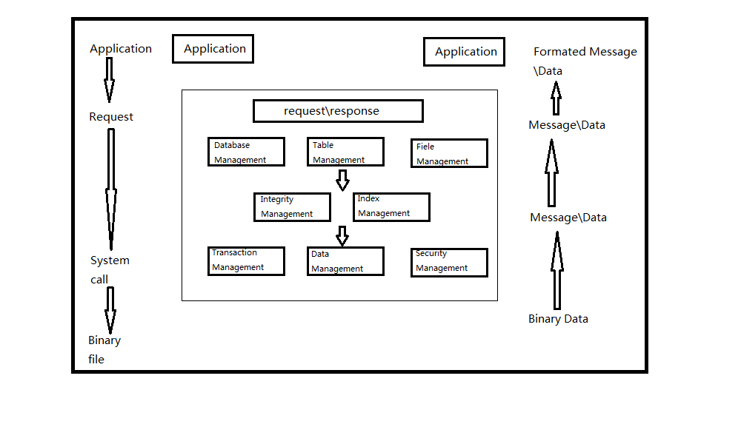.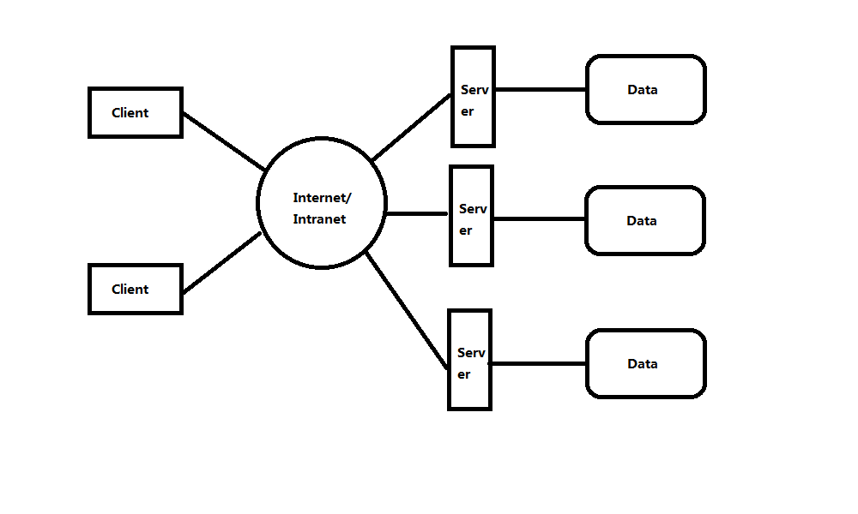

Design Considerations
    - Design Alternatives
Analyze several alternatives of system design scheme, and specify the scheme that shall be used.
- Program structure design

- Data Storage
    - Design Constraints
      - Standards compliance
Describe standards that software system shall comply with. Hardware Limitations 硬件限制
Describe hardware limitations of the software system.
The minimum configuration of the hardware: CPU: 1GHZ
RAM: 128MB

To ensure that the game can run smoothly, the configuration best meet the following requirements:
CPU: 1.8GHZ

RAM: 1G
      - Technology Limitations
Describe technology limitations of the software system.
Must use C++ and MFC.
Parallel operation: Allow multiple games running at the same time, and can ensure the correctness and completeness of the data.

Coding standard: COE programming standard requirement of Ruanko Lab

    - Other Design Considerations
Describe other design considerations of the software system.
In order to make easily use of DBMS,UI program should be clear.
- Level 1 Design Description

System Architecture
    - Description of the Architecture
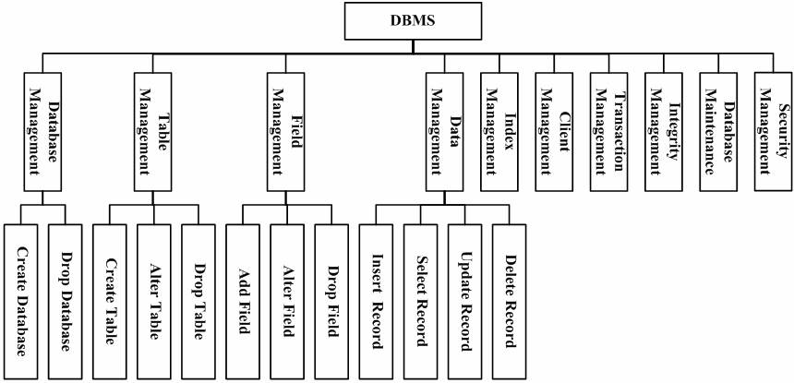

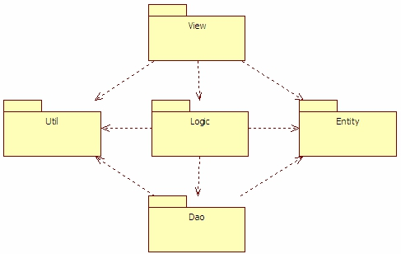

This system is divided into two main parts of the database server project and database enterprise manager. The client is a SDI project. The server is a dialog project.The project name is SuperDBMS.
    - Representation of the Business Flow
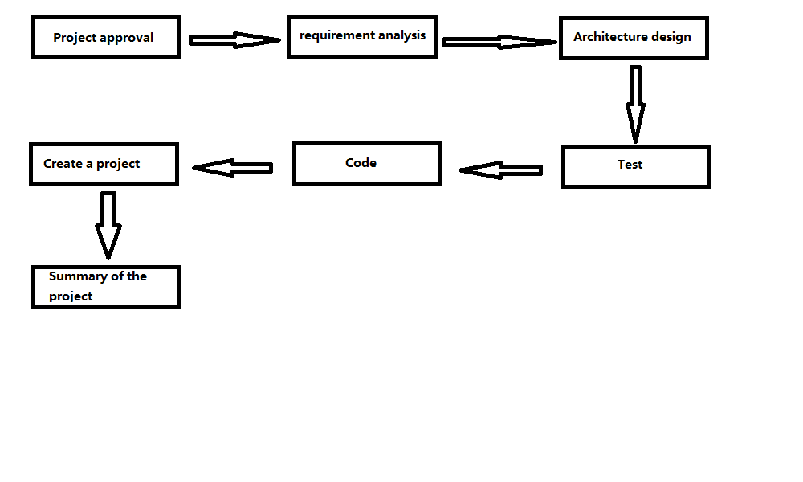

Decomposition Description

    - Database Management
- Overview
Database creation, modification and deletion. Data modification and query

- Functions
Module Name | Funtion name | Function Description
Database Manage | Create Database | The function of  Create database
 | Drop Database | The function of  delete database

    - Table Management
1.Overview
Table creation, modification and deletion. Data modification and query

2.Functions
Module Name | Funtion name | Function Description
Table Manage | Create Table | The function of  Create table
 | Drop Table | The function of  delete table
 | Alter Table | The function of modify table

    - Field Management
1.Overview
Finish the functions of table field additon, modification and deletion. Implement table field definition file creation, modification and query
2.Functions

Module Name | Funtion name | Function Description
Field Management | Add Field | In created table, add fields. Corresponding SQL statement: ALTER TABLE
  ADD COLUMN .
 | Alter Field | Modify the field information in the table. Corresponding SQL statement: ALTER TABLE
  MODIFY COLUMN .
 | Drop Field | Delete the field in the table. Corresponding SQL statement: ALTER TABLE
  DROP COLUMN .

    - Data Management
1.Overview
Implement the functions of data storage, update, modification and query.
2.Functions

Module Name | Funtion name | Function Description
Data Management | Insert Record | Insert a record into the database table. Corresponding SQL statement: INSERT INTO
  VALUES .
 | Update Record | Update the record in the database table. Corresponding SQL statement is: UPDATE
  SET = [ WHERE ].
 | Select Record | Query all the records in the table. Corresponding SQL statement is: SELECT * FROM
  [ WHERE ].
 | Delete Record | Delete the record in the table. Corresponding SQL statement is: DELETE FROM
  [ WHERE ].

    - Index Management
Establish the index for the key field in the database table. In the data operation, optimize the query with the index.
    - Client Management
Implement the client-server structure. The client can connect to main servers. The server can provide service for many clients.
    - Transaction Management
Implement transaction management function in the database.
    - Integity Management
Implement the functions of database integrity constraint check and management.
    - Database Maintenance
Implement the functions of database backup and recovery.

    - Security Management
Implement user management, permission management.

Dependency Description
This project is a Windows window program and depends on the operating system. The data storage depends on the file management system of the operating system. The communication between the server and client depends on TCP/IP network communication protocol.
- Level 2 Design Description (Optional)
Each module that is defined in L1 and identified for further description shall be stated by separate sub-sections as mentioned below. More sub-section levels could be added optionally, and finally all specific classes corresponding to each final minimal module, including its public attributes and pubic methods, should be defined.
This will be repeated for each package/module as follows.

Module Name 1
Don't actually write "Module name (1)". Specify the name of the module in few words.
    - Design Description
Depict the decomposition of the modules e.g. the functionality of each sub modules. The design classes should be defined here, class diagrams could be used to describe the design classes and the relationships among these classes, and the design pattern(s) should also be interpreted.
This will be repeated for each class as follows.
      - Class name1
Should be replaced by a true design class name.
Specific classes corresponding to each final minimal module should be defined as below.
(1) Overview
Overview of its responsibilities.

(2) Definition (Optional)
Class diagrams or pseudo codes could be used to depict the class definitions in detail，if it is not described previously. All the public attributes and methods should be defined specifically.
      - Class name2
(1) Overview
(2) Definition (Optional)

    - Function Illustration
Sequence diagrams or collaboration diagrams, etc. could be used to represent the relationships among the design classes and how the design classes implement their typical responsibilities.

Module Name 2
    - Design Description
      - Class name1
      - Class name2
    - Function Illustration

- Data Structure/Database Design
Design and describe the data storage format.
- UI Design
Describe the design of each user interface
- Detailed Design of Module

Data Structure
    - Overview
    - Class Diagram
Class diagram, if not described in HLD.
    - Attributes
The common data structure should be described here.
Visibility | Name | Type | Brief descriptions
    - Methods
Every method should be described.
      - Method1
(1) Method Descriptions
Prototype
Description
Calls
Called By
Input
Output
Return
Exception

(2) Implementation Descriptions
Pseudo codes could be used to depict the method definitions. This is the most important part of LLD.
      - Method2

Class2 Design

